**Experiment 2.4**

**Student Name:** Sahil Kaundal **UID:** 21BCS8197

**Branch:** CSE (Lateral Entry)  **Section/Group:** 616/A

**Semester:** 6th **Date of Performance:** 21/04/2023

**Subject Name:** Mobile Application Development Lab **Subject Code:** 20CSP-356

1. **Aim:**

Create an Android application using Fragments.

1. **Objective:**

* Understanding of the interactions between user interface and underlying application infrastructure.
* Design an android application which uses fragments in android studio.

1. **System Requirements:**

* Microsoft Windows 7/8/10 (32-bit or 64-bit)
* 4 GB RAM minimum, 8 GB RAM recommended (plus 1 GB for the Android Emulator)
* 2 GB of available disk space minimum, 4 GB recommended (500 MB for IDE plus 1.5 GB for Android SDK and emulator system image)
* 1280 x 800 minimum screen resolution
* Java JDK5 or later version
* Java Runtime Environment (JRE) 6 Android Studio

1. **Steps/Program:**

**activity_main.xml**

<?xml version="1.0" encoding="utf-8"?>

<RelativeLayout xmlns:android="http://schemas.android.com/apk/res/android"

xmlns:app="http://schemas.android.com/apk/res-auto"

xmlns:tools="http://schemas.android.com/tools"

android:layout_width="match_parent"

android:layout_height="match_parent"

android:textAlignment="center"

tools:context=".MainActivity">

<FrameLayout

android:id="@+id/frameLayout"

android:layout_width="match_parent"

android:layout_height="600sp"/>

<Button

android:id="@+id/fragment1btn"

android:layout_width="150sp"

android:layout_height="60sp"

android:backgroundTint="@color/black"

android:text="Fragment 1"

android:layout_alignParentBottom="true"

android:layout_marginBottom="50sp"

android:layout_marginStart="50sp"/>

<Button

android:id="@+id/fragment2btn"

android:layout_width="150sp"

android:layout_height="60sp"

android:backgroundTint="@color/black"

android:text="Fragment 2"

android:layout_alignParentBottom="true"

android:layout_alignParentRight="true"

android:layout_marginBottom="50sp"

android:layout_marginStart="50sp"/>

</RelativeLayout>

**MainActivity.java**

package com.example.exp7;

import androidx.appcompat.app.AppCompatActivity;

import androidx.fragment.app.Fragment;

import androidx.fragment.app.FragmentManager;

import androidx.fragment.app.FragmentTransaction;

import android.os.Bundle;

import android.view.View;

import android.widget.Button;

public class MainActivity extends AppCompatActivity {

Button firstFragmentBtn, secondFragmentBtn;

@Override

protected void onCreate(Bundle savedInstanceState) {

super.onCreate(savedInstanceState);

setContentView(R.layout.activity_main);

firstFragmentBtn = findViewById(R.id.fragment1btn);

secondFragmentBtn = findViewById(R.id.fragment2btn);

firstFragmentBtn.setOnClickListener(v -> replaceFragment(new fragment1()));

secondFragmentBtn.setOnClickListener(v -> replaceFragment(new fragment2()));

}

private void replaceFragment(Fragment fragment) {

FragmentManager fragmentManager = getSupportFragmentManager();

FragmentTransaction fragmentTransaction = fragmentManager.beginTransaction();

fragmentTransaction.replace(R.id.frameLayout,fragment);

fragmentTransaction.commit();

} }

**fragment1.java**

package com.example.exp7;

import android.os.Bundle;

import androidx.fragment.app.Fragment;

import android.view.LayoutInflater;

import android.view.View;

import android.view.ViewGroup;

public class fragment1 extends Fragment {

View view;

@Override

public View onCreateView(LayoutInflater inflater, ViewGroup container,

Bundle savedInstanceState) {

// Inflate the layout for this fragment

view = inflater.inflate(R.layout.fragment_fragment1, container, false);

return view;

}

}

**fragment_fragment1.xml**

<?xml version="1.0" encoding="utf-8"?>

<RelativeLayout xmlns:android="http://schemas.android.com/apk/res/android"

xmlns:tools="http://schemas.android.com/tools"

android:layout_width="match_parent"

android:layout_height="match_parent"

android:background="@color/cardview_dark_background"

tools:context=".fragment1">

<TextView

android:layout_width="wrap_content"

android:layout_height="wrap_content"

android:text="Fragment 1"

android:textSize="30sp"

android:layout_centerInParent="true"

android:textColor="@color/black"/>

</RelativeLayout>

**fragment_fragment2.xml**

<?xml version="1.0" encoding="utf-8"?>

<RelativeLayout xmlns:android="http://schemas.android.com/apk/res/android"

xmlns:tools="http://schemas.android.com/tools"

android:layout_width="match_parent"

android:layout_height="match_parent"

android:background="@color/cardview_light_background"

tools:context=".fragment2">

<TextView

android:layout_width="wrap_content"

android:layout_height="wrap_content"

android:text="Fragment 2"

android:textSize="30sp"

android:layout_centerInParent="true"

android:textColor="@color/black"/>

</RelativeLayout>

**fragment2.java**

package com.example.exp7;

import android.os.Bundle;

import androidx.fragment.app.Fragment;

import android.view.LayoutInflater;

import android.view.View;

import android.view.ViewGroup;

public class fragment2 extends Fragment {

View view;

@Override

public View onCreateView(LayoutInflater inflater, ViewGroup container,

Bundle savedInstanceState) {

// Inflate the layout for this fragment

view = inflater.inflate(R.layout.fragment_fragment2, container, false);

return view;

}

}

1. **Result/Output:**

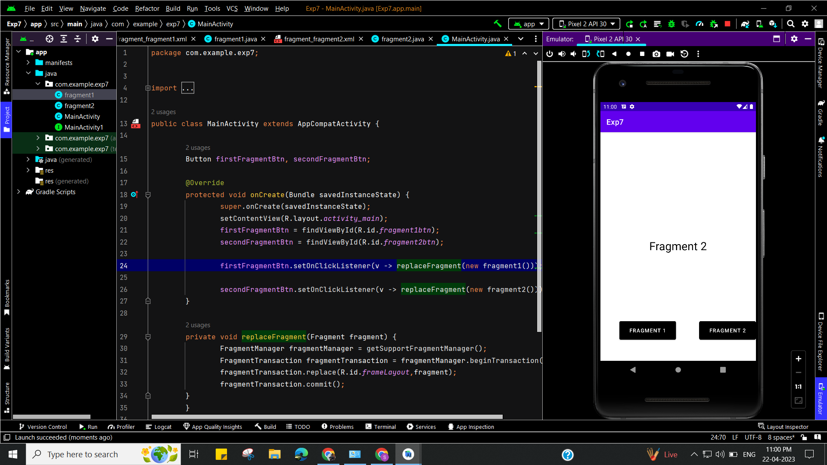

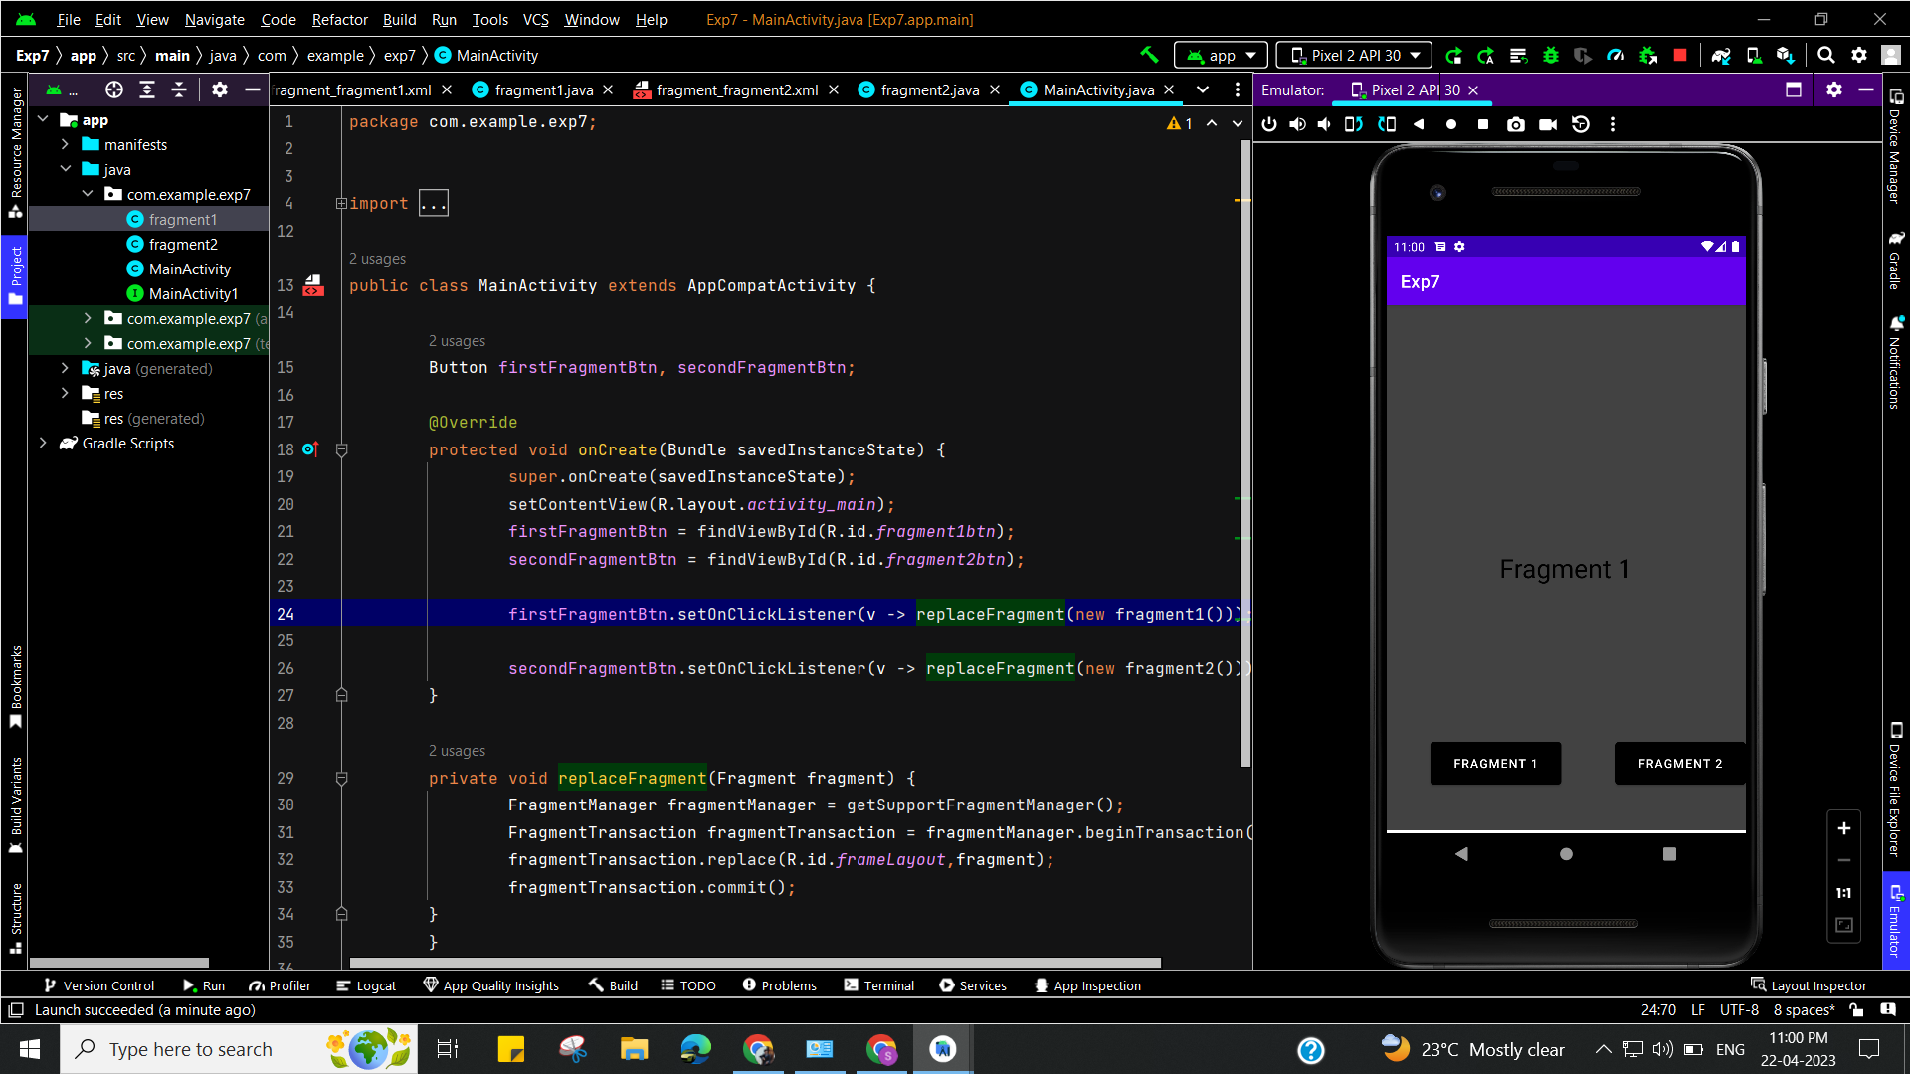

**Learning outcomes (What I have learnt):**

* To design an android application which uses fragments in android studio.
* Learnt about running application on android studio.